Rendering Manager Technical Design

Revision History

Issue | Date | Person | Reason
0.1 | March 01, 2002 | Darryl Long | Created
1.0 | April 12, 2002 | Darryl Long | Reviewed by team and released
1.1 | April 16, 2002 | Devin Murnane | Revisions reviewed by Darryl and released

Description

Introduction
The Rendering Manager is responsible for rendering the game world and its contents and maintaining the Pure3D context. It must track the rendering states of any potentially visible objects. The Rendering Manager must draw all visible objects in no longer than 1 / 60th of a second to sustain a high quality of playability.

Requirements
- Draw the contents of the game world when the game state is GAMEPLAY
- Render as few objects as possible without popping
- Allow up to 4 player views each with its own camera
- Create and maintain the Pure3D context and view(s)
- Allow other components to register and un-register a view for drawing – for instance, the GUI would register a GUI view and the Rendering Manager will tell the GUI when it is time to draw things
- Only draw certain views depending on game state – for instance, only draw the menus in the Front End
- Provide an interface to set the camera associated with a particular view
- Provide an interface to set the presence and appearance of fog in a view
- Provide an interface for the Load Manager to set the contents of the GAMEPLAY view – that is, the viewable objects in the game world

Features – Designer

- Blur effect for bullet time
- Counter measure particle effects (debris)
- Explosion effects
  - Dynamically light vertices in area
- Particle effects for explosions
- Particle effects for driving across terrain
  - Varies depending on terrain type
- Skid marks
  - Vary depending on terrain
- Highlight of opponent/target vehicle
  - Arrow or other geometry
  - Glow effect
- NIS System (to be defined)

Feature – Artistic (wish list)

- Support for custom Simpsons shaders
- Toon Line Shader
  - Much easier for artists than generating toon line geometry
  - Generate toon lines in pipeline
- Animated Textures
- Billboard Quads
- Breakable Props
  - Replace with texture animation and/or particle effects when destroyed
- Movable Props
  - Physics Objects as in the previous game
  - Particle effect
- Skid marks and track particle systems
- Hedge, fire hydrant, etc. particle systems
- Volumetric Headlights
- Shadow volumes
- Collision particle effects between vehicles
  - Varies depending on impact intensity
  - Smoke from damaged vehicle
- Exhaust particle system (trucks, Frink’s hovercar)
- Billboard fog
- Facial Animation (Is this my problem?)
- Distant objects fade into/out of visibility to minimize popping as GTA3
- Transparency sorting
- Animated physics objects (drawbridge, train, etc.)
- Texture swapping for damage states of vehicles (cracked windows, etc.)
- Full body character models when in car
- Actual models instead of sprite for low resolution model state

References
- Looked at the Rendering Manager from SRR
- Talked to Joe McGinn about design features (04-03-2002)
- Talked to Yayoi about artistic features (04-02-2002)

Technical Design

Relationships
The Rendering Manager handles the game world rendering, but other components will want to register their own rendering services with the Rendering Manager. For instance, the GUI system will want to take over the video output when the front-end is active. Also, the HUD will want to display over top of the game play screen.

The Rendering Manager must provide an interface for other components to register things to draw and set the game states in which that stuff is rendered.

The Rendering Manager must also track the world data it is to render, so there is some relationship between the Load Manager and the Rendering Manager although this is through a Pure3D chunk handler and not a direct relationship. The rendering Manager implements a p3d chunk handler for pre-processed scene graph data to minimize the amount of run-time additions to the scene graph.

The mission manager loads a mission script file and all objects specific to the mission are added to the rendering Manager explicity by the mission manager.

Obviously, there is a heavy dependency on Pure3D.

Interface

ParticleManager

The Particle Manager maintains provides an interface for adding and removing particle systems from the world. It will also automatically remove particle systems that have expired.

class ParticleSystemObject : public WorldObject
{
public:
GridParticle();
~GridParticle( void );

void Display();
void Reset();

unsigned int GetFrameDrawn(void){ return frameDrawn; };
void SetFrameDrawn(unsigned int frame){ frameDrawn = frame; };

unsigned int GetViewDrawn(void){ return viewDrawn; };
void SetViewDrawn(unsigned int view){ viewDrawn = view; };

void SetParticleSystem(tParticleSystemInstance* particleSytem );
tParticleSystemInstance* GetParticleSystem(void) { return mParticleSystem; };

void CreateParticleInstance(tParticleSystemInstance* particleSytem );

void SetTransform(rmt::Vector i) { translate = i; };

bool GetInUse(void) { return inUse; };
void SetInUse(bool flag) { inUse = flag; };
};

class ParticleManager : public IRenderable
{
public:
ParticleEffects( void );
~ParticleEffects( void );

void Render( void );
void Update( unsigned int timeDelta );
void Setup(void);
void Cleanup(void);

void CreateParticleEffect( WorldObject* pObj, rmt::Vector& worldPos, float intensity );
void CreateStaticParticleEffect( WorldObject* pObj, rmt::Vector& worldPos, float intensity );
void CreateDynamicParticleEffect( WorldObject* pObj, rmt::Vector& worldPos, float intensity );
};

Using the ParticleManager, you can add new particle systems into the world and create new systems. The ParticleManager doesn’t actually instantiate new systems at run time; it recycles a pool of particle systems. Thus, there is a maximum number of available systems.

RenderingManager

The Rendering Manager controls the Pure3D views and the context and provides methods to perform special rendering tasks on the views.

enum LayerEnum
{
LAYER_GAMEPLAY,
LAYER_HUD,
LAYER_GUI,
NUM_LAYERS
};

interface IRenderable
{
void Display();
};

class RenderWatcher
{
public:
void BeforeRender( LayerEnum layer );
void AfterRender( LayerEnum layer );

void Update( float elapedTime );
};

class RenderingManager : public Manager
{
public:
void Render();

void AddRenderable(IRenderable* renderable, LayerEnum layer);
void RemoveRenderable(IRenderable* renderable, LayerEnum layer);

void AddWorldObject(DSGObject* obj);
void RemoveWorldObject(DSGObject* obj);

void AddRenderWatcher( RenderWatcher* watcher, LayerEnum layer);
void RemoveRenderWatcher( RenderWatcher* watcher, LayerEnum layer );

void SetFogState( FogProperties fogProps );
void SetBlurState( BlurProperties blurProps );

void QueryRadius( rmt::Vector position, float radius, WorldObject** objs );

};

The rendering Manager divides its rendering tasks into Levels. IRenderables are considered to be a member of one (and only one) of the levels, and levels are rendered in the order from 0 to NUM_LAYERS-1. LayerEnum is used to specify which layer an IRenderable belongs to.

The rendering Manager will call the Display() method for each IRenderable that has been added. When the context is changed, the rendering Manager automatically dumps the entire list of IRenderables. Use the LevelEnum to specificy the drawing order. As IRenderables are added to the rendering Manager it sorts them in order of level.

The rendering Manager maintains a scene graph of all world objects. The rendering Manager performs culling and optimization to draw only the objects actually visible. This is for run-time addition and removal from the scene graph only (such as traffic vehicles and pedestrians), not for loading.

To find all the objects within a spherical radius of a position, use the QueryRadius method. It returns an array of World Objects.

The rendering Manager allows other components to register a RenderWatcher object that is notified before and after each level is rendered. Each level corresponds to a Pure3D tView.

Component Class Diagrams
The rendering Manager implements a proprietary spatial partitioning algorithm for fast culling and searching of world objects and static geometry. This algorithm uses six clipping planes defining a frustrum as an input to create a visible set of geometry. This geometry is drawn using the IRenderable::Display method.

The main class in this system is the SpatialTree class, which maintains a one-dimensional array of ContiguousBinNodes. This makes data access faster than a pointer-rich structure such as a binary tree, especially on the cache-senstive PS2.

The Spatial Tree system, as a whole, is referred to as the Devin’s Scene Graph, or DSG. It is used to store all the movable and static World Objects (called DSGObjects), and all the world geometry.

Each node of the spatial tree defines a plane. The world is split by this plane, and all geometry on the non-visible side of the plane is culled. The depth (or granularity) of the tree is platform specific and tuned to perform optimally on each platform.

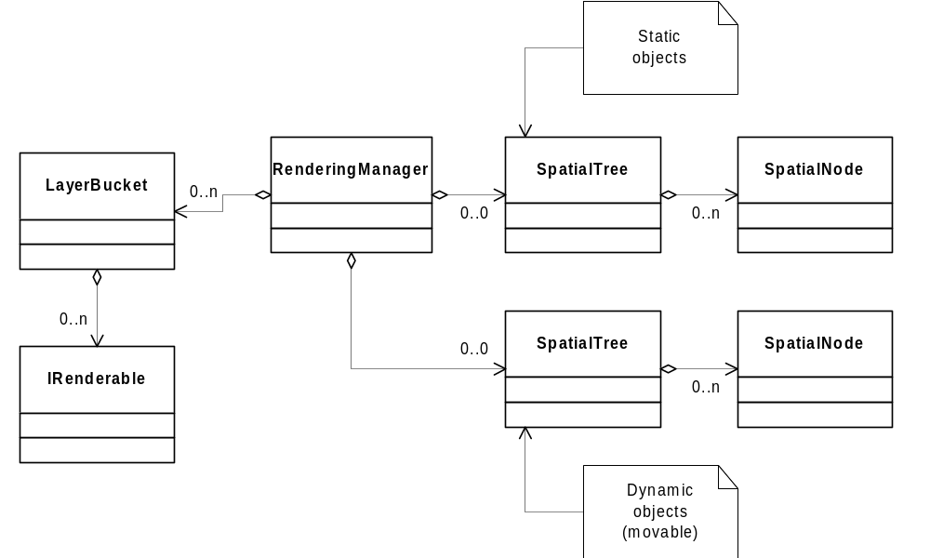

template <class T> class SpatialNode
{
public:
SpatialNode();
~SpatialNode();

AAPlane3f mSubDivPlane;
ReserveArray<T*> mSpatialElems;

//Debug
BoxPts mBBox;

protected:
};

template <class T> class ContiguousBinNode
{
public:
ContiguousBinNode();
ContiguousBinNode( T& irData );
~ContiguousBinNode();

ContiguousBinNode<T>* LChild();
ContiguousBinNode<T>* RChild();

int LChildOffset();
int RChildOffset();

int GetSubTreeSize(); //SubTreeSize is the number of nodes in the subtree not including the node called
void SetSubTreeSize( int iSubTreeSize );

bool IsRoot();

ContiguousBinNode<T>* Parent();
void LinkParent( int iParentOffset );

//Previously Asymetric
ContiguousBinNode<T>* LSibling();
ContiguousBinNode<T>* RSibling();
int RSiblingOffset();

enum
{
//msNoChildren = -1,
msNoChildren = 0,

msNoParent = 0,
};

T mData;
protected:
int mSubTreeSize;
int mParentOffset;

};

template <class T> class SpatialTree
{
public:
SpatialTree();
~SpatialTree();

void Generate( OctTreeNode* ipTreeRoot, Bounds3f& irTreeBounds );

ContiguousBinNode< SpatialNode<T> >* GetRoot();

Bounds3f& GetBounds();
};

Use Cases

IRenderable

The first case is for adding a new IRenderable to the rendering Manager. You must have a class which implements the IRenderable interface, such as:

class MainMenu : public IRenderable
{
public:
void Display();
LevelEnum GetLevel() { return ( LEVEL_GUI ); }
};

When the context switches to the Front End context, the instance of MainMenu is created and added to the rendering Manager.

mMainMenu = new MainMenu();
GetRenderingManager()->AddRenderable( mMainMenu );

When the context switches from the Front End context, the mMainMenu renderable is automatically dumped from the rendering Manager, so it is safe to destroy mMainMenu.

delete mMainMenu;

The implementation of MainMenu::Display() may be as follows:

void MainMenu::Display()
{
mLogo->Render(); // mLogo is a tDrawable
mMenu->Render(); // mMenu is a Scrooby thing
// etc.
};

World Objects (DSGObject)

The second case is for adding DSGObject instances into the scene graph. As an example, the Traffic Manager creates AI controlled traffic vehicles around the player character, but always attempts to spawn them outside the field of view. Each time a new traffic vehicle is created, it is added to the rendering Manager.

GetRenderingManager()->AddWorldObject( newTrafficVehicle );

When that vehicle passes outside the field of view once again, it is destroyed after being removed from the scene graph.

trafficVehicle = GetNextDeadVehicle();
GetRenderingManager()->RemoveWorldObject( trafficVehicle );
delete trafficVehicle;

Render Watchers

The third case deals with registering a RenderWatcher. In this case, the Presentation Manager wants to perform a transition effect from an NIS to the gameplay screen. The desired transition is a wipe from left to right. To do this, the PM registers two RenderWatchers.

transWatcher = new WipeLeftRenderWatcher();

GetRenderingManager()->AddRenderWatcher( transWatcher, LAYER_NIS );
GetRenderingManager()->AddRenderWatcher( transWatcher, LAYER_GAMEPLAY );

In the implementation of the WipeLeftRenderWatcher, we set the size of the current View to only display up to (or start from) the wipe index, which increase each frame from left to right.

void WipeLeftRenderWatcher::BeforeRender( LayerEnum layer )
{
if ( layer == LAYER_NIS )
{
GetCurrentView()->SetLeft( mLeftIndex );
}
else
if ( layer == LAYER_GAMEPLAY )
{
GetCurrentView()->SetRight( mLeftIndex );
}
}

void WipeLeftRenderWatcher::Update( float elapsedTime )
{
currentTime = elapedTime – mStartTime;

if ( currentTime < mTransitionTime )
{
mLeftIndex = ( GetScreenWidth() * currentTime / mTransitionTime );
}
else
{
SetDone( true );
}
}

